Ride Analysis (using SQL)
Name: Maitreyee Khachane
Course: Data Analytics
Batch: CX-167-MOR-JAN-OFFLINE

1. Project Overview
This project analyses ride data from a ride-hailing service to understand revenue patterns, rider behaviour, service performance, and operational efficiency. The objective is to identify key business insights such as peak demand hours, most profitable services, and high-performing routes to support data-driven decision-making.

2. Dataset Summary
- Rows: 50,000
- Columns: 13
Key Features:
- Ride details (ride_id, date, time, ride_status)
- Location data (source, destination)
- Ride metrics (distance, duration)
- Financial data (ride_charge, misc_charge, total_fare)
- Service & payment details (services, payment_method)
- Data Quality: Dataset is clean with no major missing values

3. Data Preparation using SQL
- Standardised column formats for consistency
- Filtered completed rides for accurate revenue analysis
- Created calculated metrics such as fare per km
- Verified data integrity (valid ride status, numeric fields)
- Created reusable views for reporting

4. Data Analysis using SQL
Total rides – Calculated the total number of rides to understand overall business activity.
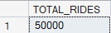
Service types – Identified different service types available on the platform.
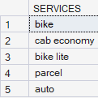
Average distance – Analysed the average distance travelled per ride.
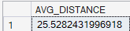
Total revenue – Calculated total revenue generated from all rides.
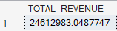
Payment methods – Examined the distribution of payment methods used by customers.
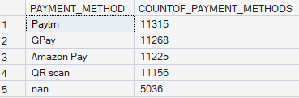
Completed rides – Filtered and analyzed only successfully completed rides.
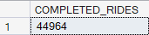
Revenue by service – Compared revenue contribution across different service types.
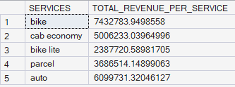

Most used routes – Identified frequently used routes based on ride count.
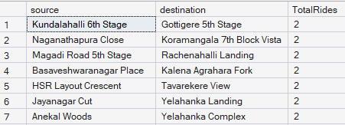
Service ranking – Ranked services based on their revenue contribution.
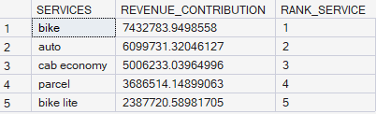
Peak demand hours – Identified hours with the highest ride demand.
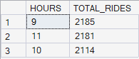
Summary view – Created a summarized dataset for overall performance analysis.
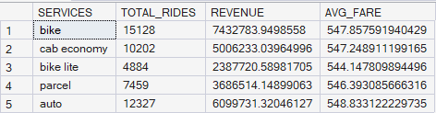

5. Business Insights
- Most profitable service: Bike generates the highest revenue
- Peak demand hours: 9 am to 11 am
- Customer behaviour: Users prefer digital payments
- Ride pattern: Most rides are medium distance with consistent duration
- Route insight: No single route dominates; demand is distributed

6. Business Recommendations
- Optimise Peak Hours → Allocate more drivers during peak time (9–11 AM)
- Focus on High-Revenue Services → Promote BIKE and AUTO services
- Improve Pricing Strategy → Analyse fare per km for better margins
- Control Misc Charges → Monitor unusually high additional charges
- Enhance Payment Experience → Strengthen digital payment systems

7. Conclusion:
This project provides a comprehensive analysis of ride data to understand revenue patterns, service performance, and customer behaviour. The findings highlight that bike services contribute significantly to overall revenue, while demand varies across different hours of the day, indicating clear peak periods. Customer preferences show a strong inclination toward digital payment methods, and ride patterns suggest consistent usage with moderate travel distances.
Overall, the analysis helps in identifying key operational insights such as high-performing services, demand trends, and route distribution. These insights can support better decision-making, improve resource allocation, and enhance overall business efficiency.

